

12 PHYSICS

ELECTRICITY & MAGNETISM
ELECTRIC FIELDS

A charged object has an electric field associated with it, and this influences other charged objects placed in it.

The electric field strength is defined as the force per unit charge.

i.e.

where E = the electric field intensity (NC⁻¹)
F = the force exerted on the charged object in the
electric field (N)
q = the size of the charge on the object in the
electric field (C)

Electric field has both size (strength) and direction, hence it is a vector.

The direction of an electric field is taken as the direction a positive test charge, when placed in the field, would move.

i.e. away from a positively charged object.
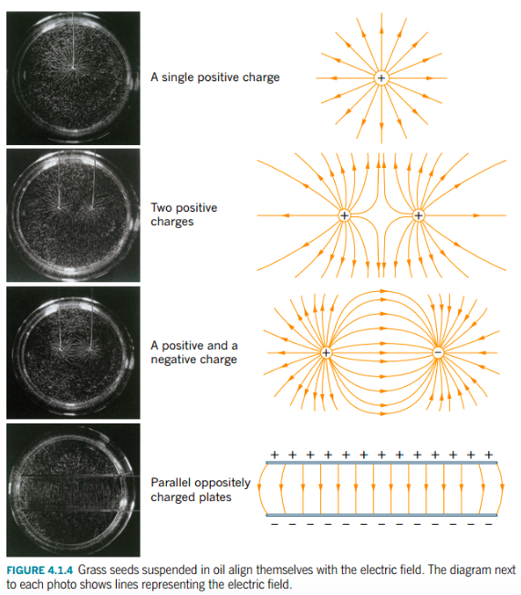

An electric field is represented by lines of force or flux lines.

The electric field around various point and plate charges are as shown.

Rules For Drawings

1. Electric field lines never touch nor cross each other.

2. They enter and leave surfaces at right angles.

3. The intensity of the electric field is represented by the density or "bunching" of the field lines.

Examples

Draw the electric fields associated with the following.

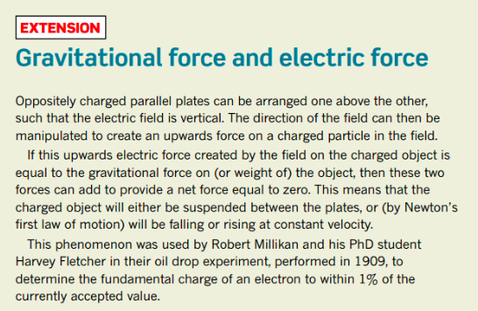
ELECTRIC POTENTIAL

The Earth is defined as having zero potential.

Charged bodies gain electrical potential energy when they are moved in an electric field.

Consider a positively charged body that cannot move and is insulated from the Earth.

If a positive charge is brought to point B,
work has to be done to overcome the
repulsion.

This work is stored as electric potential
energy.

If it is moved to point A, it has a higher
electrical potential energy.

Points A and B have different potentials -
there is a potential difference.

Potential difference is therefore defined as the work done per unit charge in moving the charge through an electric field.

i.e.

where V = the difference in potential between two points in an electric field (V - volts)
W = work done in moving the charge (J)
q = the amount of charge moved in the electric field (C)

When a charge is placed in an electric field, it experiences a force and moves. It moves from one potential to another, thus requiring some work to be done.

If work is done in moving the charge, it must change E_{k}.

i.e. W = ΔE_{k}
=> Vq = ¹/₂ mv² - ¹/₂mu²

Since the charge starts from rest, ¹/₂ mu² = 0.

∴ W = Vq = ¹/₂mv²

This Physics principle of accelerating charges is best considered in the electron gun inside an old-style TV (cathode ray tube).
Example
The electrons inside the "red" electron gun of a standard colour TV are accelerated by a potential difference of 1.32 x 10³ V. Determine how fast these electrons leave the gun to move down the picture tube.

V = 1.32 x 10³ V
m = 9.11 x 10⁻³¹ kg
q = 1.60 x 10⁻¹⁹ C
$$\text{W} \text{ = } \text{Vq} \text{ =} \frac{\text{1}}{\text{2}}\text{m}{\text{v}}^{\text{2}}$$
$$\text{ ⇒ }\text{v } \text{= } \sqrt{\frac{\text{2Vq}}{\text{m}}}$$
$$\text{= } \sqrt{\frac{\text{2}\left(\text{1.32 x }{\text{10}}^{\text{3}}\right)\left(\text{1.60 x }{\text{10}}^{\text{-19}}\right)}{\text{9.11 x }{\text{10}}^{\text{-31}} }}$$
$$\text{= } \text{2.15 x }{\text{10}}^{\text{7}}\text{ m}{\text{s}}^{\text{-1}}\text{ forwards}$$

Electric Potential in Parallel Plates

The electric field lines between parallel plates are arranged as follows. For calculations, no "end effect" will be considered and the field is uniform throughout.

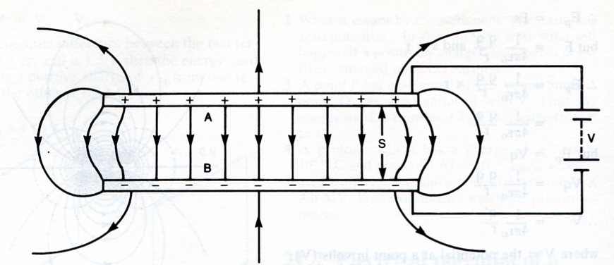
End effect - non-uniform electric field.

The electric field intensity between the plates is given by:

where E = electric field intensity (Vm⁻¹)
V = potential difference across the plates (V)
d = distance between the plates (m)

Note
This relationship only applies to parallel plates.

Combining $\text{E = }\frac{\text{F}}{\text{q}}$ and $\text{E = }\frac{\text{V}}{\text{d}}$ gives:

Examples

1. Electron Gun - used to accelerate electrons in older style TVs and computer monitors.

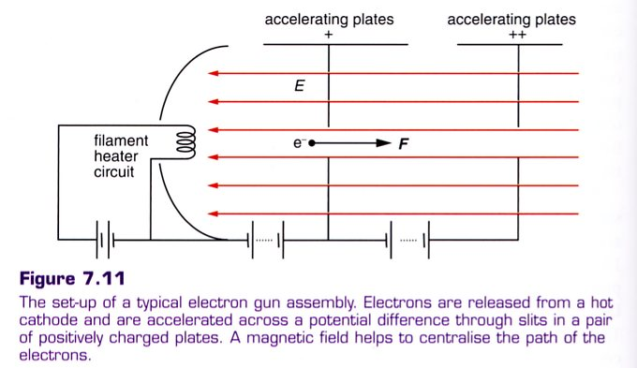

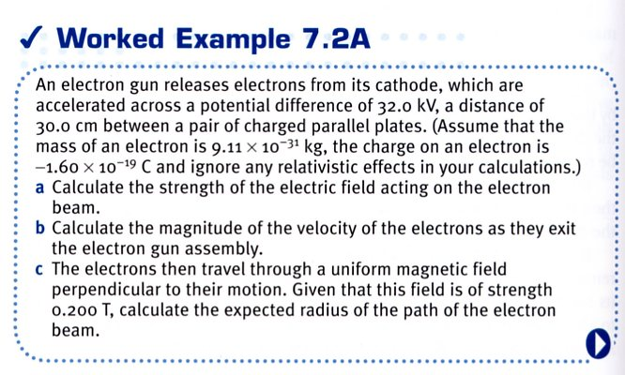
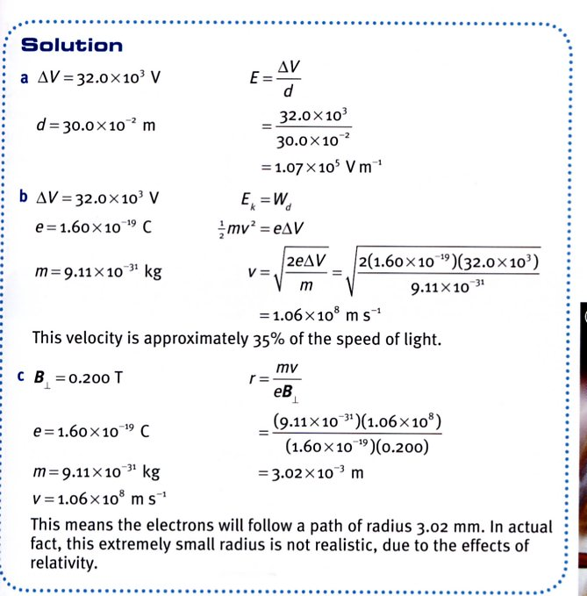

2. Two parallel copper plates are 5.00 cm apart in a vacuum and have a potential difference of
1.00 x 10³ V applied across them. Calculate:

(a) the electric field intensity between them.
(b) the force on an electron placed in the field.
(c) the velocity with which an electron will return to the positive plate if it is released from
rest at the negative plate.

(a) $\text{E = }\frac{\text{V}}{\text{d}}\text{ = }\frac{\text{1.00 x }{\text{10}}^{\text{3}}}{\text{5.00 x }{\text{10}}^{\text{-2}}}\text{ = 2.00 x }{\text{10}}^{\text{4}}\text{ V}{\text{m}}^{\text{-1}}$

(b) $\text{F = Eq = (2.00 x }{\text{10}}^{\text{4}}\text{)( 1.60 x }{\text{10}}^{\text{-19}}\text{) = 3.20 x }{\text{10}}^{\text{-15}}\text{ N}$

(c) $\text{W = Vq = }\frac{\text{1}}{\text{2}}\text{ m}{\text{v}}^{\text{2}}$ $$\text{ ⇒ }\text{v } \text{= } \sqrt{\frac{\text{2Vq}}{\text{m}}}$$
$$= \sqrt{\frac{2(\text{1.00 x }{\text{10}}^{\text{3}}\text{)}\left(\text{ 1.60 x }{\text{10}}^{\text{-19}}\right)}{\left( \text{9.11 x }{\text{10}}^{\text{-31}}\right)}}$$

$$= \text{8.38 x }{\text{10}}^{\text{7}}\text{ m}{\text{s}}^{\text{-1}}\text{ towards the +ve plate}$$

3. Deflection Plates In Cathode Ray Tubes (CRT)

A set of horizontal plates 2.00 cm long with a potential difference of 2.00 x 10² V across them
is used to deflect electrons in an old TV set. An electron moving at 4.50 x 10⁶ ms⁻¹ is fired
down the axis of the plates (in the middle). If the plates are 4.00 cm apart with the positive
plate on top, determine the following.

(a) Calculate the acceleration of the electron due to the electric field.
(b) Should the effect of the acceleration due to gravity be considered?
(c) Calculate the vertical displacement of the electron while travelling between the plates.
2.00 cm
4.00 cm
4.50 x 10⁶ ms⁻¹

(a) ${\text{F}}_{\text{E}}\text{ = Eq = } \frac{\text{Vq}}{\text{d}}\text{ =} \frac{\text{(2.00 x }{\text{10}}^{\text{2}}\text{)( 1.60 x }{\text{10}}^{\text{-19}}\text{)}}{\text{(4.00 x }{\text{10}}^{\text{-2}}\text{)}}\text{ = 8.00 x }{\text{10}}^{\text{-16}}\text{ N}$

${\text{F}}_{\text{E}}\text{ = ma ⇒ a = }\frac{{\text{F}}_{\text{E}}}{\text{m}}\text{ = }\frac{\text{(8.00 x }{\text{10}}^{\text{-16}}\text{)}}{\text{(9.11 x }{\text{10}}^{\text{-31}}\text{)}}\text{ = 8.78 x }{\text{10}}^{\text{14}}\text{ m}{\text{s}}^{\text{-2}}$

(b) The effect of gravity can be ignored. The acceleration of the force due to the electric field is 10¹⁴ times greater.

(c) The electron undergoes a similar path to a projectile moving horizontally under the effect of gravity.

Horizontally: ${\text{v}}_{\text{h}}\text{ =} \frac{{\text{s}}_{\text{h}}}{\text{t}}\text{ ⇒ t = }\frac{{\text{s}}_{\text{h}}}{{\text{v}}_{\text{h}}}\text{ =} \frac{\text{(2.00 x }{\text{10}}^{\text{-2}}\text{)}}{\text{(4.50 x }{\text{10}}^{\text{6}}\text{)}}\text{ = 4.44 x }{\text{10}}^{\text{-9}}\text{ s}$

Vertically:

v = ? s = ut + $\frac{\text{1}}{\text{2}}$at²
u = 0.0 ms⁻¹ = 0 + $\frac{\text{1}}{\text{2}}$ (8.78 x 10¹⁴)(4.44 x 10⁻⁹)²
a = 8.78 x 10¹⁴ ms⁻² = 8.67 x 10⁻³ m
t = 4.44 x 10⁻⁹ s
s = ? ∴ Electron moves 8.67 mm upwards

ELECTROMOTIVE FORCE (EMF - ε)

In order to move charges, a source of electrical potential energy must do work on them.

Such sources include torch cells, solar cells, photovoltaic cells, generators, piezoelectric crystals, and thermocouple junctions.

These devices are referred to as sources of electromotive force or EMF (ε ). This is a misnomer as the term refers to the energy given to the charges rather than any force that is applied to them.

EMF is defined as the amount of work done per unit charge in moving the charges through the source.

STATIC ELECTRICITY

The outer electrons of atoms are very easily removed as they are held relatively weakly by the attraction of the protons in the nucleus. This is easily achieved by rubbing materials together.

When two materials are rubbed together, electrons are transferred between them. One material will gain electrons (and gains a nett negative charge due to having more electrons than protons present), and the other will lose electrons (and gain a nett positive charge).

This build up of charge is called static electricity.

e.g. Consider the build up of charge when walking on certain carpets.

Law Of Electrostatics

Like charges repel, unlike charges attract.

If the charge build up on two objects is great enough, and these charges are opposite in sign, then a spark may jump between the two.

It is this effect that is responsible for lightning discharging between clouds and the Earth.

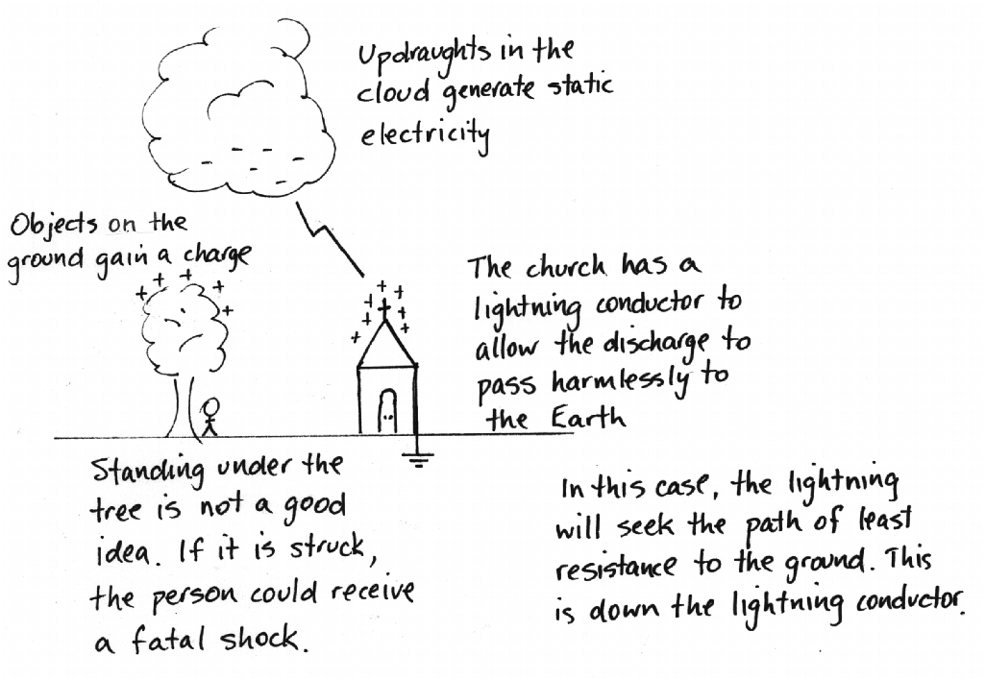

Fundamental Charge

The elementary charge (e) is given as that charge on a proton or electron.

i.e. e = 1.60 x 10⁻¹⁹ C (Where C represents the units - Coulombs)

FORCE BETWEEN CHARGES

Coulomb's Law is used to describe the force between charged objects.

i.e.

where F = the force of attraction or repulsion (N)
q₁, q₂ = the charges on the objects (C)
d = the distance between the two objects (m)
ε_{o} = the dielectric constant (permittivity) for the
medium (C²N⁻¹m⁻²)

Note
The permittivity of air (ε_{air}) is almost the same as that of a vacuum (ε_{o}).

Therefore, in calculations use:
ε_{air} = ε_{o} = 8.85 x 10⁻¹² C²N⁻¹m⁻²

Remember

If the charges are similar in sign, the force is repulsive.

If the charges are opposite in sign, the force is attractive.

Example 1
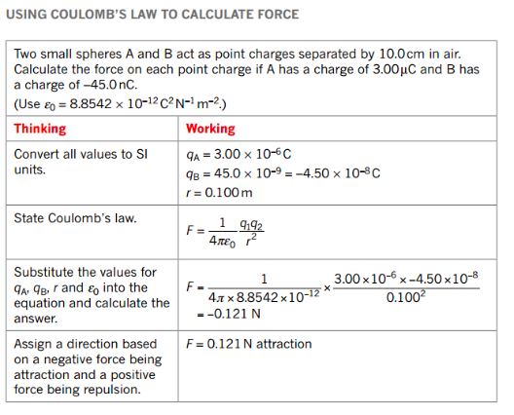

Example 2
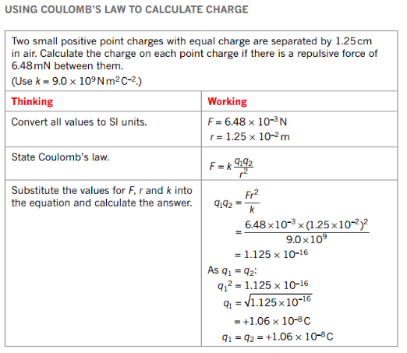
Example 3
Three point charges are arranged in air as shown below. They are at the vertices of an equilateral triangle of side 10.0 cm.

Calculate the force on the charge at A due to the presence of the other charges.
(Assume that the charges are fixed and can't move relative to each other.)

F_{C} = 89.9 N
R
60.0°
θ
60.0°
-10.0 μC
+10.0 μC
C
A
-10.0 μC
B
F_{B} = 89.9 N

$${\text{F}}_{\text{B}}\text{ = }\frac{\text{1}}{\text{4π}{\text{ε}}_{\text{o}}}\text{.}\frac{{\text{q}}_{\text{A}}{\text{q}}_{\text{B}}}{{\text{d}}^{\text{2}}}$$
$$\text{= }\frac{\text{1}}{\text{4π}\left(\text{8.85 x }{\text{10}}^{\text{-12}}\right)}\text{.}\frac{\left(\text{10.0 x }{\text{10}}^{\text{-6}}\right)\left(\text{10.0 x }{\text{10}}^{\text{-6}}\right)}{{\left(\text{0.100}\right)}^{\text{2}}}$$
$$\text{= 89.9 N}$$
$$\text{=} {\text{F}}_{\text{C}} \left(\text{since all charges are equal in magnitude}\right)$$

$$\overset{\text{→}}{\text{R}}\text{ = }\sqrt{{\left(\text{89.9}\right)}^{\text{2}}\text{ + }{\left(\text{89.9}\right)}^{\text{2}}\text{ - 2}\left(\text{89.9}\right)\left(\text{89.9}\right)\text{cos 60.0°}}$$
$$\text{= 89.9 N}$$

$$\text{Given that }\overset{\text{→}}{\text{R}}\text{ = 89.9 N, }\text{by inspection }\text{θ = 60.0° }\left(\text{since an isosceles triangle is formed}\right)\text{.}$$

∴ $\overset{\text{→}}{\text{R}}\text{ = 89.9 N at 60.0 ° to the direction AC}$

Elecric Field At A Distance From A Charge

It is useful to be able to determine the electric field at a distance from a single point charge.

$$\text{Since E =} \frac{\text{F}}{\text{q}}\text{ and F =} \frac{\text{1}}{\text{4π}{\text{ε}}_{\text{o}}}\text{.}\frac{{\text{q}}_{\text{1}}{\text{q}}_{\text{2}}}{{\text{d}}^{\text{2}}}\text{ :}$$
$$\text{E = }\frac{\text{1}}{\text{4π}{\text{ε}}_{\text{o}}}\text{.}\frac{\text{q}}{{\text{d}}^{\text{2}}}$$

where q = the point charge (C)

Example

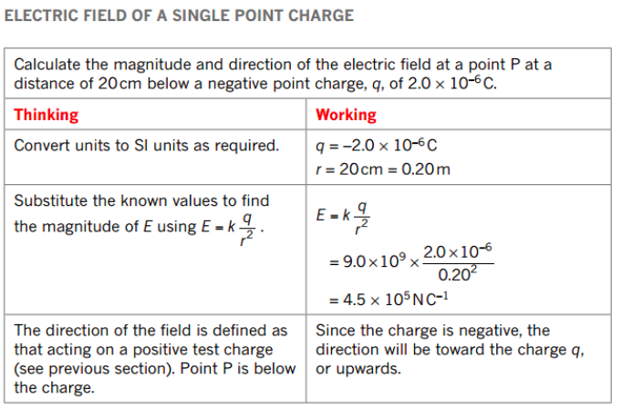

PROPERTIES OF MAGNETS

A freely-suspended piece of magnetic material will always come to rest pointing along a north-south line with respect to the Earth’s magnetic field. This is called the directional property of magnets.

The end that points to the north pole is called the north-seeking pole, leading to it being called the north pole of the magnet.

Iron filings scattered over a magnet will concentrate near the ends of the magnets.
i.e. The magnetic force is strongest at the poles.

The poles of magnets will interact if brought near one another.
i.e. Like poles repel, unlike poles attract.
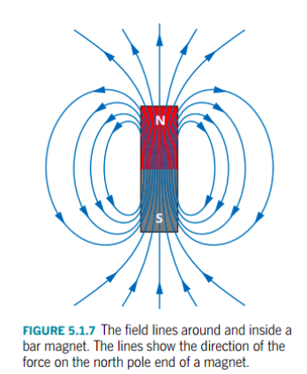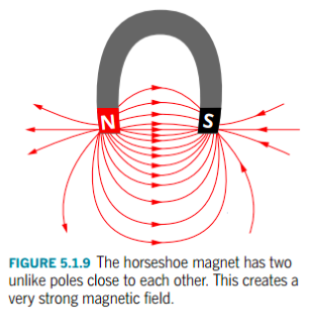

MAGNETIC MATERIALS

Magnetic materials are those that can be magnetised.

e.g. Fe, Co, Ni and certain alloys of these elements show strong magnetic properties.

Magnetic materials can be classified as follows.

1. Ferromagnetic - strongly attracted.

e.g. Fe, Ni, Co, alnico (alloy of Al, Ni, Co, Fe), permalloy (alloy of Fe, Ni)

2. Paramagnetic - weakly attracted.

e.g. Mn, Al, liquid O₂, Pt

3. Diamagnetic - weakly repelled.

e.g. Cu, Au, Bi

MOLECULAR THEORY OF FERROMAGNETISM

Ferromagnetic materials have their atoms grouped in isolated fragments called domains.

Within each of these domains, the atoms are aligned in such a way that their magnetic fields (due to their moving and spinning electrons - see notes on Magnetic Fields of Current-Carrying Wires.) combine, so that each domain can be thought of as a tiny magnet.

In an unmagnetised material, the domains are arranged randomly.

When a magnetic field is applied to the material, the domains align so that they point in the same direction as the field. One end becomes the north pole, the other the south pole.

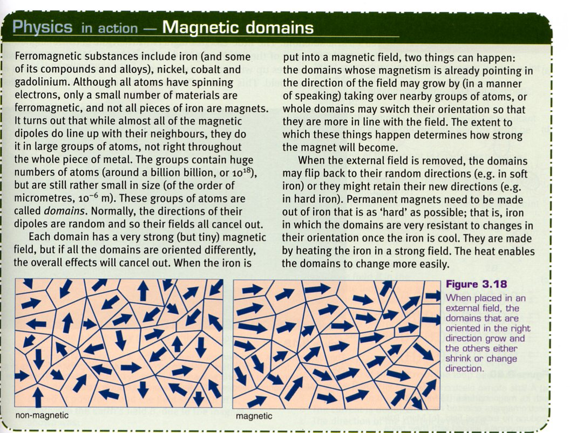

LINES OF MAGNETIC FLUX

When iron filings are sprinkled onto a sheet of paper with a bar magnet underneath, they align themselves with the magnetic field present.

Any region in which a magnetic material experiences a force due to its proximity to a magnet is said to contain a magnetic field.

The direction of the field at any point is taken as the direction of a force on the north pole of a magnet placed in the field at that point.

Magnetic fields are shown using lines of magnetic flux. These are lines whose shape is such that the tangent at any point gives the direction of the magnetic field at that point.

Arrowheads on the flux lines show the direction of the force acting on the north pole of a small test compass needle placed at that point.

i.e. The flux lines are always out of north and into south.

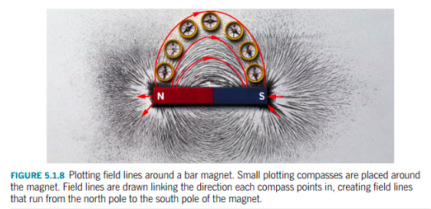

To fully describe a magnetic field at a point, both a magnitude (or strength) and a direction must be given.
i.e. It is a vector quantity.

This vector is called the magnetic flux density (B). It can also be referred to as magnetic intensity or magnetic induction.

The magnitude of the magnetic flux density is given as the number of flux lines passing through a unit area.

In a uniform magnetic field:

where φ = magnetic flux (Webers - Wb)
B = magnetic flux density (Wbm⁻² or Tesla - T)
A = area through which the flux acts (m²)

Example 1

A circular coil of diameter 30.0 cm is arranged to be at right angles to a magnetic field of strength 2.56 x 10⁻³ T. Calculate the total amount of flux passing through it.

Example 2

If the coil in example 1 is changed to be at 60.0 ° to the field, what is the new value for the flux threading the coil?

INTERACTION BETWEEN MAGNETIC FIELDS

1. Unlike Poles

The fields combine to produce a new magnetic field in which the lines of magnetic force
become denser.

∴ The magnets attract one another.

2. Like Poles

The magnetic fields are operating in opposite directions, resulting in a new magnetic field in
which the lines of magnetic force become less dense.

∴ The magnets repel one another.

Examples

1. Draw the magnetic fields that exist between the magnets in the following situations.

2. Draw the magnetic fields associated with the following.

(a) A circular magnet.

(b) A flat plastic fridge magnet.

EARTH’S MAGNETIC FIELD

The Earth is surrounded by a magnetic field known as the magnetosphere. It is thought that electric currents generated within the core of the Earth cause the magnetic field to arise.
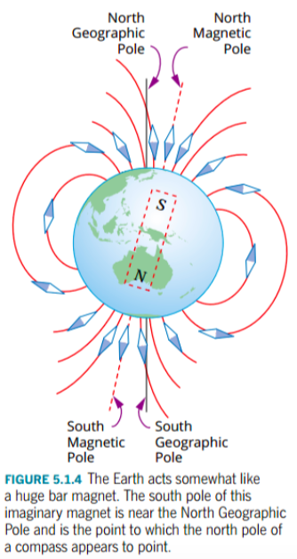
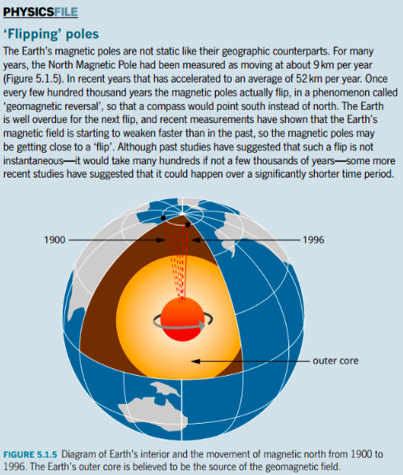

As stated previously, the directional property of a magnetic material arises because the north-seeking pole is attracted to the magnetic north pole of the Earth.

Is this wrong, considering that like poles repel? No!

The north-seeking pole is attracted to a south pole.

∴ The north magnetic pole of the Earth acts as if it is the south pole of a bar magnet.

Consequently, when drawing the Earth’s magnetic field, the field lines come out of the south magnetic pole and enter into the north magnetic pole.

Notice also that the geographic poles and the magnetic poles do not coincide. In fact the magnetic poles continue to “wander” each year, changing their positions relative to the true north and south poles.

Angle Of Declination: the angle between true north and magnetic north.

This angle depends on the point on the Earth’s surface, but all maps will carry “corrections” to allow navigators to find true north. Maps need to have these “corrections” updated each year as the magnetic poles move.
Any freely-suspended magnetic needle can also “dip” at an angle to the horizontal as it follows the Earth’s magnetic field line.

Angle Of Dip: angle between the horizontal and the line of the magnetic field at that point.

Consequently, the Earth's magnetic field has a vertical and horizontal component at all points except at the magnetic poles.

Example

A circular coil of radius 25.0 cm is arranged vertically in an east-west direction in Perth. Calculate the amount of flux that threads the coil, given the magnetic field intensity at Perth is 5.80 x 10⁻⁵ T at 66.0° dip.

MAGNETIC FIELD AROUND A CURRENT-CARRYING CONDUCTOR

All moving charges produce a magnetic field, whether within a conductor or moving through space as in an atom.

i.e. Magnetism is created by moving charges.

e.g. Spinning electrons in an atom produce a field. If electrons are paired, they spin in opposite
directions and their fields cancel.

Ferromagnetic atoms such as iron have unpaired electrons that produce a magnetic field for
the atom.

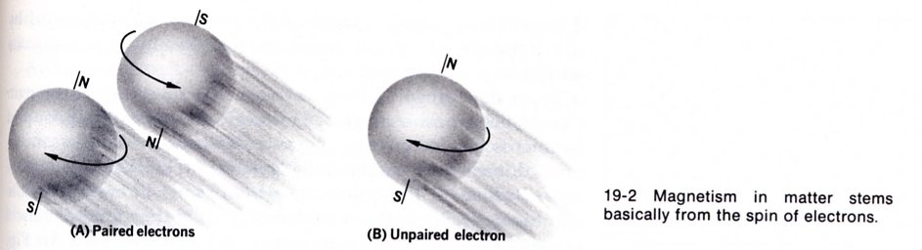

Electrons orbiting in an atom produce a field.
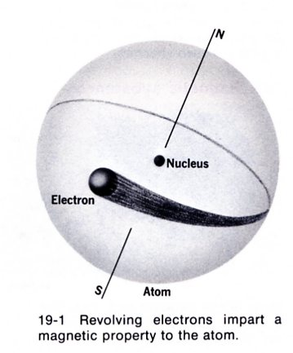

A moving positive charge produces a field.
+
X X X
Magnetic field out of page

Note
The direction of the field for an isolated charge is given by the Right Hand Grasp Rule - see notes ahead!

The magnetic field produced by a current-carrying wire is a series of concentric circles centred on the wire. It is produced by the moving charges inside.

The direction of the magnetic field is given by the right hand grasp rule.
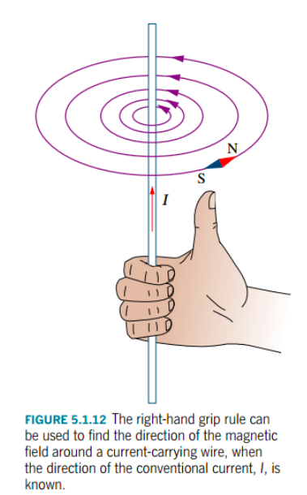

Note

Conventional Current: the flow of positive charge from the positive terminal to the
negative terminal of the source of the current.

It is easier to represent the magnetic field due to a current by a two-dimensional diagram.
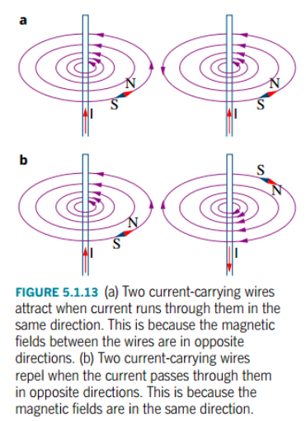

Note
The convention for the direction of the conventional current is as follows.

Make sure that you put one of these labels on the bottom of every diagram you draw so that there is no confusion for the person marking your test or exam paper.

Calculating Magnetic Field Strength

Like most fields, the closer an object is to a current-carrying wire, the stronger the magnetic field. It is also observed that the amount of current in a wire affects the magnetic field strength.

The strength of the magnetic field (B) around a wire is directly proportional to the current (I) in a long, straight conductor and inversely proportional to the distance from the conductor (r). That is:

where B = strength of the magnetic field in tesla (T)
I = current in the conductor in ampere (A)
r = distance from the conductor in metres (m)
μ₀ = the permeability of free space, μ₀ = 4π × 10⁻⁷ TmA⁻¹

B is a vector quantity, the direction being that of the magnetic field around the conductor. It is a measure of the magnetic flux density.

Example

A current of 5.00 A is running through a long straight wire. Determine the magnitude of the strength of the magnetic field at a point 10.0 cm from the wire.

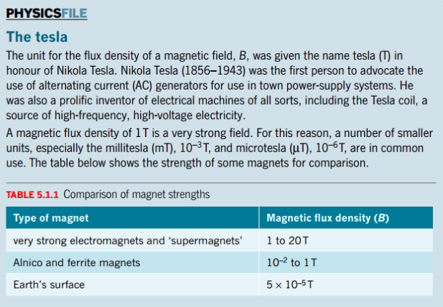
MAGNETIC FIELD AROUND A CURRENT LOOP AND A SOLENOID

Single Loop

It is much easier to show this field in a two-dimensional drawing.

The strength of the field can also be made stronger by increasing the number of loops to make a flat coil.

This leads to the formation of a solenoid.

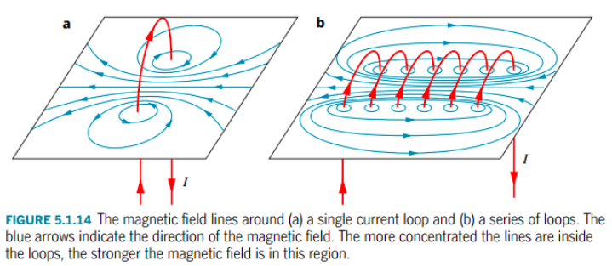

Solenoid
This contains many loops arranged in a tight cylindrical coil.

It has a uniform field inside and the external field is similar to a bar magnet.
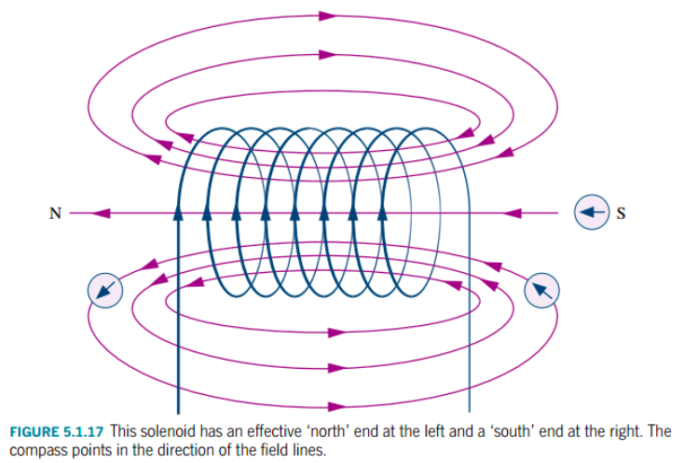

Right Hand Curl Rule: Curl the fingers of the right hand around the solenoid in the direction of
the conventional current flow and the thumb will point towards the north pole.

Note
Care must be taken to clearly identify the direction of the conventional current flow.

Examples
On the following diagrams, show the N and S poles.

FORCE BETWEEN PARALLEL CONDUCTORS

The French physicist Ampere noticed a strange phenomenon when two current-carrying wires were placed parallel and close to each other.

(a) Current in the same direction in the wires - attraction occurred.

(b) Current in the opposite directions - repulsion occurred.

The reason becomes obvious if one remembers that each wire generates a magnetic field and this can interact with any other magnetic field.

Consider the following experimental arrangement.

To determine in which direction the conductor will move, the right hand palm rule is used.

Right Hand Palm Rule: Fingers point in the direction of B, thumb points in the direction
of conventional current flow.
Palm points in the direction of the force exerted on the
conductor.

Note
More detail will be given on this in the next section of work.
We can apply this understanding to parallel conductors.

i.e. Currents in opposite directions.

Currents in the same direction.

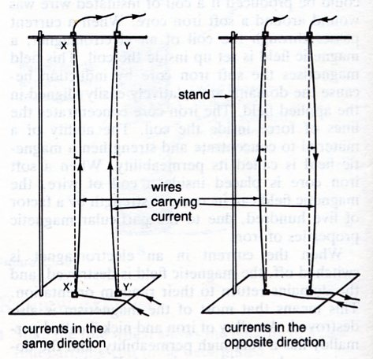
FORCE ON A CONDUCTOR IN A MAGNETIC FIELD

As seen before, a current-carrying conductor in a magnetic field produces its own field that interacts with the permanent field.

Remember that the direction of the force on the conductor is given by the right hand palm rule.

The force exerted on the conductor is given by:

where F = force (N)
I = current flowing (A)
l = length of the conductor in the magnetic field (m)
B = magnetic field strength (T)

Note

The force is greatest when the conductor is at right angles to the magnetic field.

If the conductor is at an angle to the field, then the component of B that is at right angles to
the conductor is used.

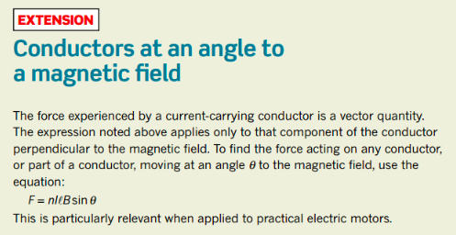

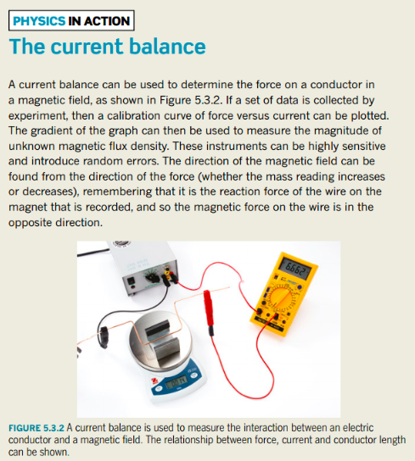

Examples

1. On the following diagrams, mark the direction of the force acting on the conductor.

2. A straight conductor carrying a D.C. current of 1.50 A is arranged horizontally in a north-
south direction in the southern hemisphere at a point where the Earth’s magnetic field
intensity is 4.86 x 10-5 T at 48.0° dip. Calculate the force exerted onto the conductor if the
length of conductor in the field is 56.0 cm and the current flows north-south.

3.
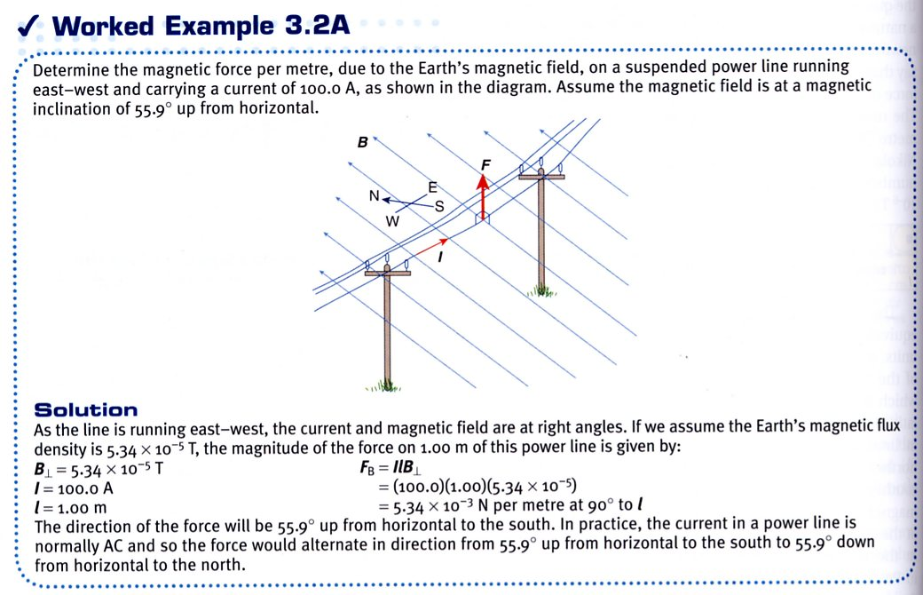

4.
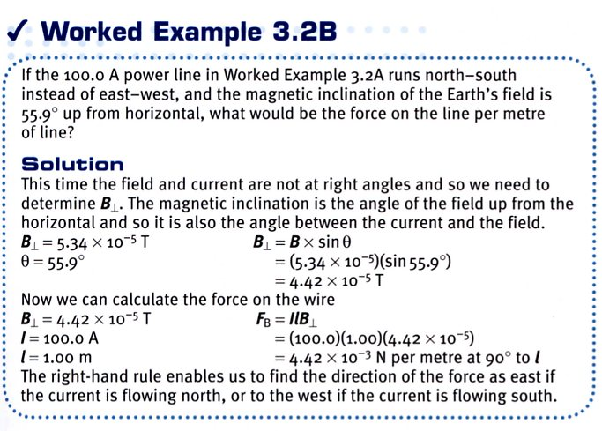

5.
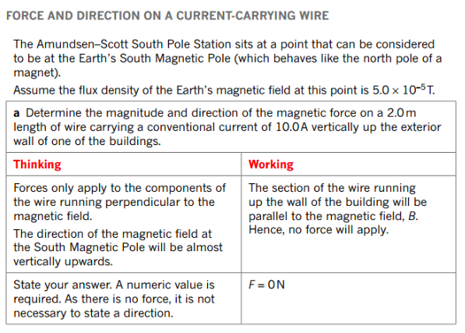
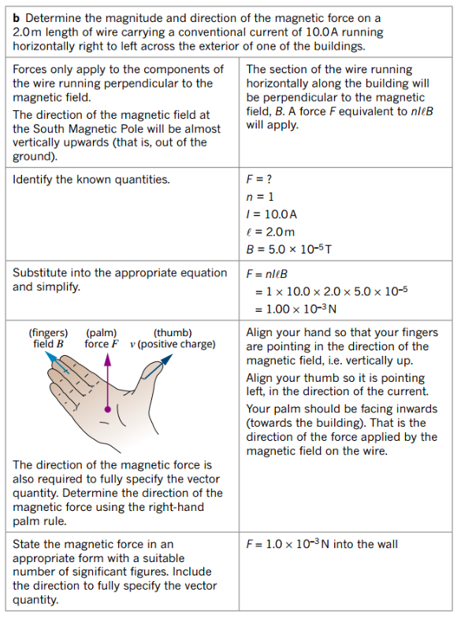
ELECTRIC MOTOR

The force exerted by a magnetic field on a current-carrying conductor has many applications, the most important being the electric motor.

The basic principle of the motor is a rectangular loop of wire that is mounted on an axle between the poles of a magnet. The loop is usually pivoted along its long axis.

A force is exerted along each side of the loop that is at right angles to the magnetic field.

These forces exert a turning effect on the coil that is in the same direction. This arrangement is called a couple.

The magnitude of the torque generated by the coil is given by:

where M = maximum torque or moment (Nm)
N = number of loops in the coil
I = the current flowing in the coil (A)
l = length of the coil at right angles to the magnetic field (m)
B = magnetic field intensity (T)
r = radius of turn of the coil (m)
= 1/2 x the length of side parallel to the magnetic field.

Note
The “2” in the formula is important as it shows the presence of the couple - two moments acting in the same direction.

Example 1
A D.C. motor has 200 turns of wire arranged into a rectangular coil of dimensions 20.0 cm x
10.0 cm. It is arranged with its long axis at right angles to a horizontal magnetic field of 0.200 T. Calculate the maximum torque generated by the coil when a current of 5.00 A flows through it.

Note
Each of the sides of the coil experiences a force due to the magnetic field. However, the magnitude varies as the coil rotates - it depends on the angle of each side to the magnetic field.

The forces on sides AB and CD create torque to turn the coil.

The forces on AD and BC only stretch the coil and have no effect on torque.

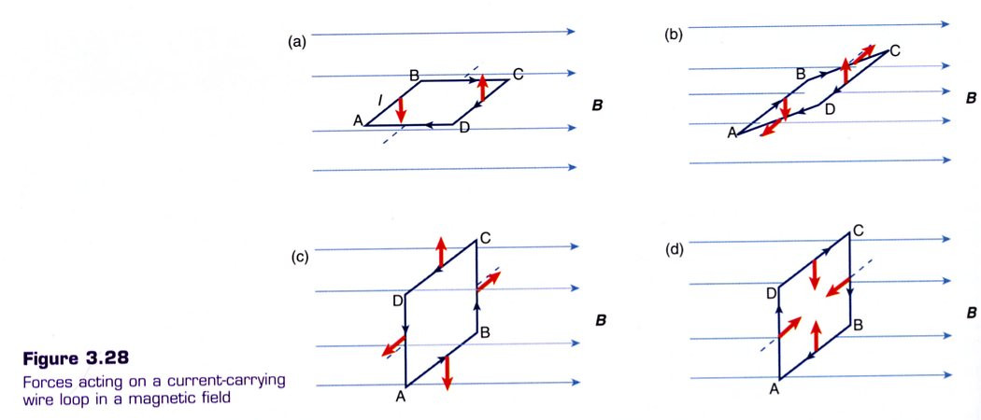
Example 2
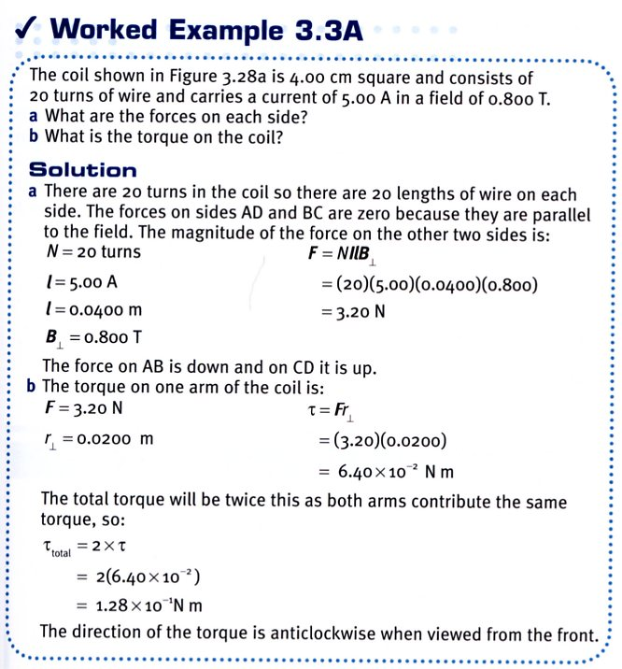
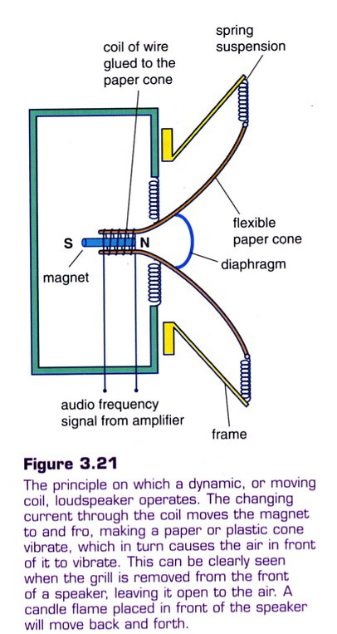

Example 3

A loudspeaker is an application of
the motor principle.

DIRECT CURRENT (D.C.) MOTOR

Consider the simple motor shown previously and what happens to the torque produced as the coil turns.

POSITION 1: Maximum turning effect in a clockwise direction.

POSITION 2: Zero turning effect.

POSITION 3: Maximum turning effect but in the opposite direction.

Commercial D.C. motors overcome the problem of a zero turning effect in position 2 by having several coils wound around a soft iron core (called an armature) at angles to each other.

The soft iron increases the magnetic effect of the electric coils by concentrating their field.

By having the coils at an angle to each other, there will always be one coil in the correct position (parallel to the magnetic field) to experience the maximum turning effect. The motor will therefore turn with a constant torque value.

The problem of the coil reversing its direction every half-turn is overcome by using a split-ring commutator. This will effectively reverse the current direction every half-turn so that the turning forces will always be turning the coil in the one direction.

The current is supplied to the commutator via small graphite or copper brushes.

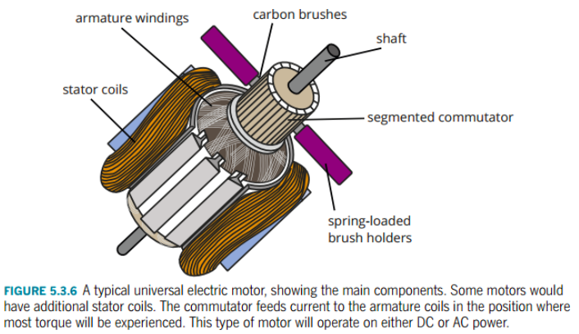

The power of the motor depends upon the total turning forces exerted on the coil.

These forces may be increased by:

• increasing the current flowing in the coil.
• increasing the strength of the magnetic field.
• increasing the number of loops in the coil.

ALTERNATING CURRENT (A.C.) MOTOR

This type of motor is called an induction motor.

It does not need a split-ring commutator as the current is switching direction 50 times a second
(50 Hz).

The construction of such a motor is complex and will not be examined in this course.

MOTION AND FORCES IN ELECTRIC AND MAGNETIC FIELDS

Electric Fields

A charged object has an electric field associated with it, and this influences other charged objects placed in it.

The electric field strength is defined as the force per unit charge.

i.e.

where E = the electric field intensity (NC⁻¹)
F = the force exerted on the charged object in the
electric field (N)
q = the size of the charge on the object in the
electric field (C)

Electric field has both size (strength) and direction, hence it is a vector.

The direction of an electric field is taken as the direction a positive test charge, when placed in the field, would move.

i.e. away from a positively charged object.

Electric Potential in Parallel Plates

The electric field lines between parallel plates are arranged as follows. For calculations, no "end effect" will be considered and the field is uniform throughout.


End effect - non-uniform electric field.

The electric field intensity between the plates is given by:

where E = electric field intensity (Vm⁻¹)
V = potential difference across the plates (V)
d = distance between the plates (m)

Note
This relationship only applies to parallel plates.

Combining and gives:

Potential difference is defined as the work done per unit charge in moving the charge through an electric field.

i.e.

where V = the difference in potential between two points in an electric field (V)
W = work done in moving the charge (J)
q = the amount of charge moved in the electric field (C)

When a charge is placed in an electric field, it experiences a force and moves. It moves from one potential to another, thus requiring some work to be done.

If work is done in moving the charge, it must change E_{k}.

i.e. W = ΔE_{k}
=> Vq = ¹/₂ mv² - ¹/₂mu²

Since the charge starts from rest, ¹/₂ mu² = 0.

∴

Note: No work is done by the electric field if the charge is NOT moved parallel to the field.

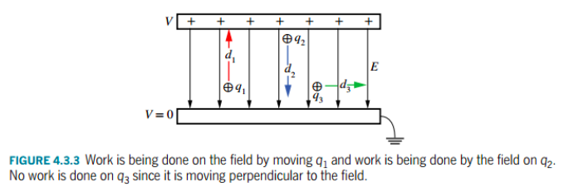

Examples

1.

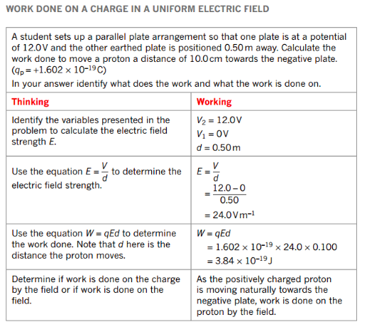
2. Electron Gun - used to accelerate electrons in older style TV's and computer monitors.







2. Two parallel copper plates are 5.00 cm apart in a vacuum and have a potential difference of
1.00 x 10³ V applied across them. Calculate:

(a) the electric field intensity between them.
(b) the force on an electron placed in the field.
(c) the velocity with which an electron will return to the positive plate if it is released from
rest at the negative plate.

3. Deflection Plates In Cathode Ray Tubes (CRT)

A set of horizontal plates 2.00 cm long with a potential difference of 2.00 x 10² V across them
is used to deflect electrons in an old TV set. An electron moving at 4.50 x 10⁶ ms⁻¹ is fired
down the axis of the plates (in the middle). If the plates are 4.00 cm apart with the positive
plate on top, determine the following.

(a) Calculate the acceleration of the electron due to the electric field.
(b) Should the effect of the acceleration due to gravity be considered?
(c) Calculate the vertical displacement of the electron while travelling between the plates.
2.00 cm
4.00 cm
4.50 x 10⁶ ms⁻¹

Magnetic Fields

The force on a current-carrying wire is due to the individual force exerted on each of the moving charges within the conductor.

For an isolated charge moving in a magnetic field, it will be deflected as it is not constrained within a conductor.

The direction of the force is again determined by the right hand palm rule. In this instance, the thumb is in the direction of the movement of a positive charge.

If the moving charge is negative, then the thumb is placed in the opposite direction to its movement.

The magnitude of the force is given by:

where F = force exerted at right angles to the path of the particle (N)
q = charge on the particle (C)
v = velocity of the particle (ms-1)
B = magnetic field intensity (T)

Note
This equation will only apply when the velocity of the charges and the magnetic field are at
right angles to each other.

A method of measuring the velocity of a beam of charged particles is to pass the beam through a crossed electric and magnetic field as shown below.

The force due to the electric field is balanced by the force due to the magnetic field and the particle passes through undeflected.

Only one velocity for the particles will allow them to pass through undeflected - hence it is called a velocity selector.

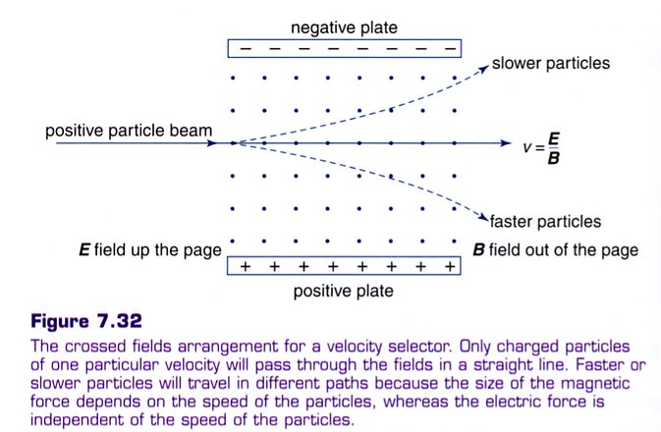
Examples
1. A beam of positrons passes undeflected through a pair of crossed electric and magnetic fields
in which the electric field intensity is 3.70 x 103 Vm-1 and the magnetic field intensity is
7.86 x 10-2 T. What must be the velocity of the positrons?

Note
The velocity of the particles is independent of the size of the charge on them.

2. A beam of negatively charged beta particles is directed south-north in a magnetic field of
3.56 x 10-2 T directed vertically upwards. If the velocity of the particles is 2.30 x 107 ms-1,
calculate the magnitude and direction of the force acting on each.

SHAPE OF THE PATH OF A CHARGED PARTICLE IN A MAGNETIC FIELD

The force exerted on a charged particle is always at right angles to its direction of travel. Thus, it does not alter the speed of the particle.

It will change its path, forcing the particle to move in a circular path.

Thus, the force that acts is a centripetal force.

i.e. Fc = F_{due} _{to B}
=> mv2/r = qvB

where r = radius of orbit of the charged particle (m)
m = mass of the particle (kg)
v = orbital speed of the particle (ms-1)
q = charge on the particle (C)
B = magnetic field intensity (T)

Example
An electron gun operating at 1.35 x 103 V is used to accelerate electrons and fire them horizontally into an evacuated chamber where a vertical magnetic field of 0.114 T is directed upwards.

(a) What is the velocity of the electrons as they enter the magnetic field?
(b) Do the electrons move clockwise or anticlockwise?
(c) What is the period of orbit of the electrons?

Examples
Below are some common examples and applications of electric charges moving in a magnetic field.

1. Television, Cathode Ray Oscilloscopes (C.R.O.)

Electrons are made to “sweep” the screen using electric coils producing magnetic fields to
deflect electrons vertically and horizontally.

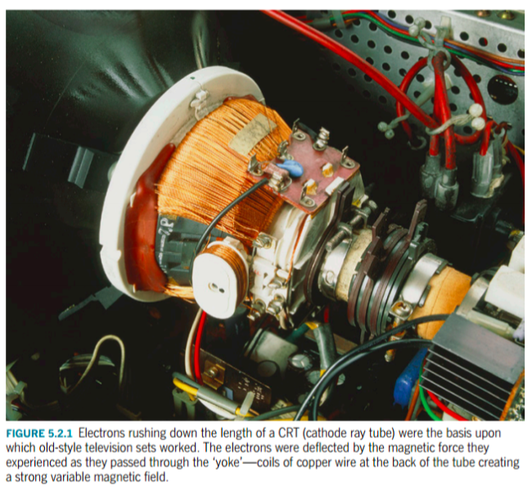
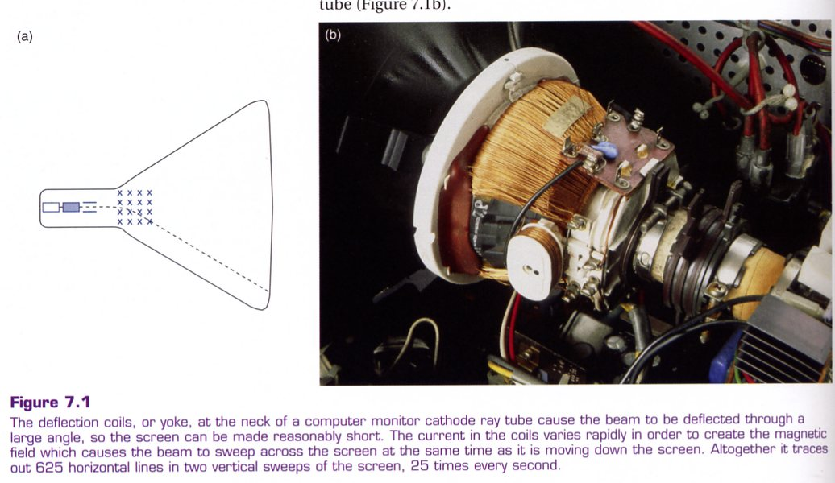

2. Mass Spectrometer

Ions and other charged particles are accelerated by electric fields and fired into a magnetic
field. The particles travel in a circular path until they collide with a detector (photographic
film in the early machines, a computer-controlled detector in recent machines).

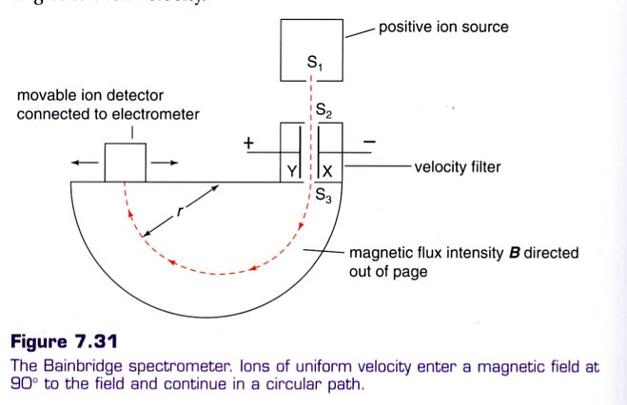

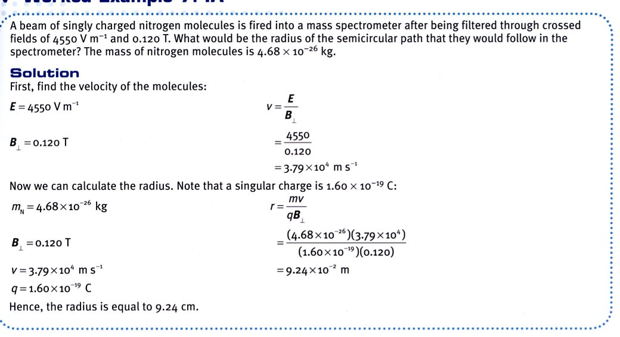

3.
